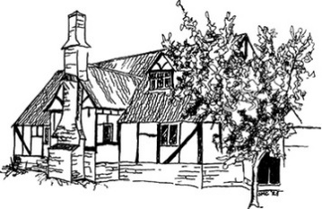
Minsterworth Village Hall
Main road, Minsterworth GL2 8JH
Telephone: 01452 750492 Registered Charity No: 255668
Email: bookingminsterworthvh@btinternet.com

APPLICATION FOR HIRE (TWO/ THREE-DAY)

Name of Hirer (minimum age 21)
Organisation (if applicable)
Contact Address
 |  |  |  |  | Post Code
Telephone (mobile)
Telephone (landline)
Email address
Purpose of hire
Day 1 (Setting up)  Day 2 (Main event)  Day 3 (Clearing up) |  | Date(s) | Access required from / until
Approx. number of attendees
Will alcohol be consumed by attendees at the event? |  |  |  | YES / NO
I intend to apply for a Temporary Event Notice for the sale of alcohol at this event |  |  |  | YES / NO
I intend to pay by Bank Transfer (preferred) or cheque (delete as appropriate) |  |  |  | Bank Transfer/Cheque
Any other special requirements

I have read and agree to abide by the terms outlined in the Minsterworth Village Hall Conditions of Hire.
Name of Hirer
Signature
Date

To secure your booking, please return the completed form to the address below complete with a non-refundable deposit of £250. Additionally, refundable noise & damage deposits of £50 & £100 respectively are required at the time of booking. Deposits can be paid by bank transfer (Sort code: 40-17-10 Account number: 61583689) or if necessary, by cheque (payable to ‘Minsterworth Village Hall’). Six months’ notice of cancellation is required when a full deposit will be returned. Cancellations between 3-6 months of the event will forfeit 50% deposit. Less than 3 months’ notice of cancellation will forfeit the full deposit.
Brian Billingham, Bookings Secretary, Minsterworth Village Hall, Main Road, Minsterworth, GL2 8JH
GDPR compliance – The personal data of the Hirer will be securely stored for the period of this booking and subsequent invoicing only. Once the booking is complete, all details will be destroyed. Minsterworth Village Hall will not pass on your contact details to a third party without your prior consent.

Please tick here if you do not wish to receive further correspondence from Minsterworth Village Hall

